Real people. Real results. Guaranteed.
1-800-345-4381
Info@MyUltraSlim.com

HEALTH HISTORY QUESTIONNAIRE
Name (Last, First, M.I.): |  |  |  | M F | DOB:
Home Address : |  |  |  |  | Phone:
Email:
Location of Services:

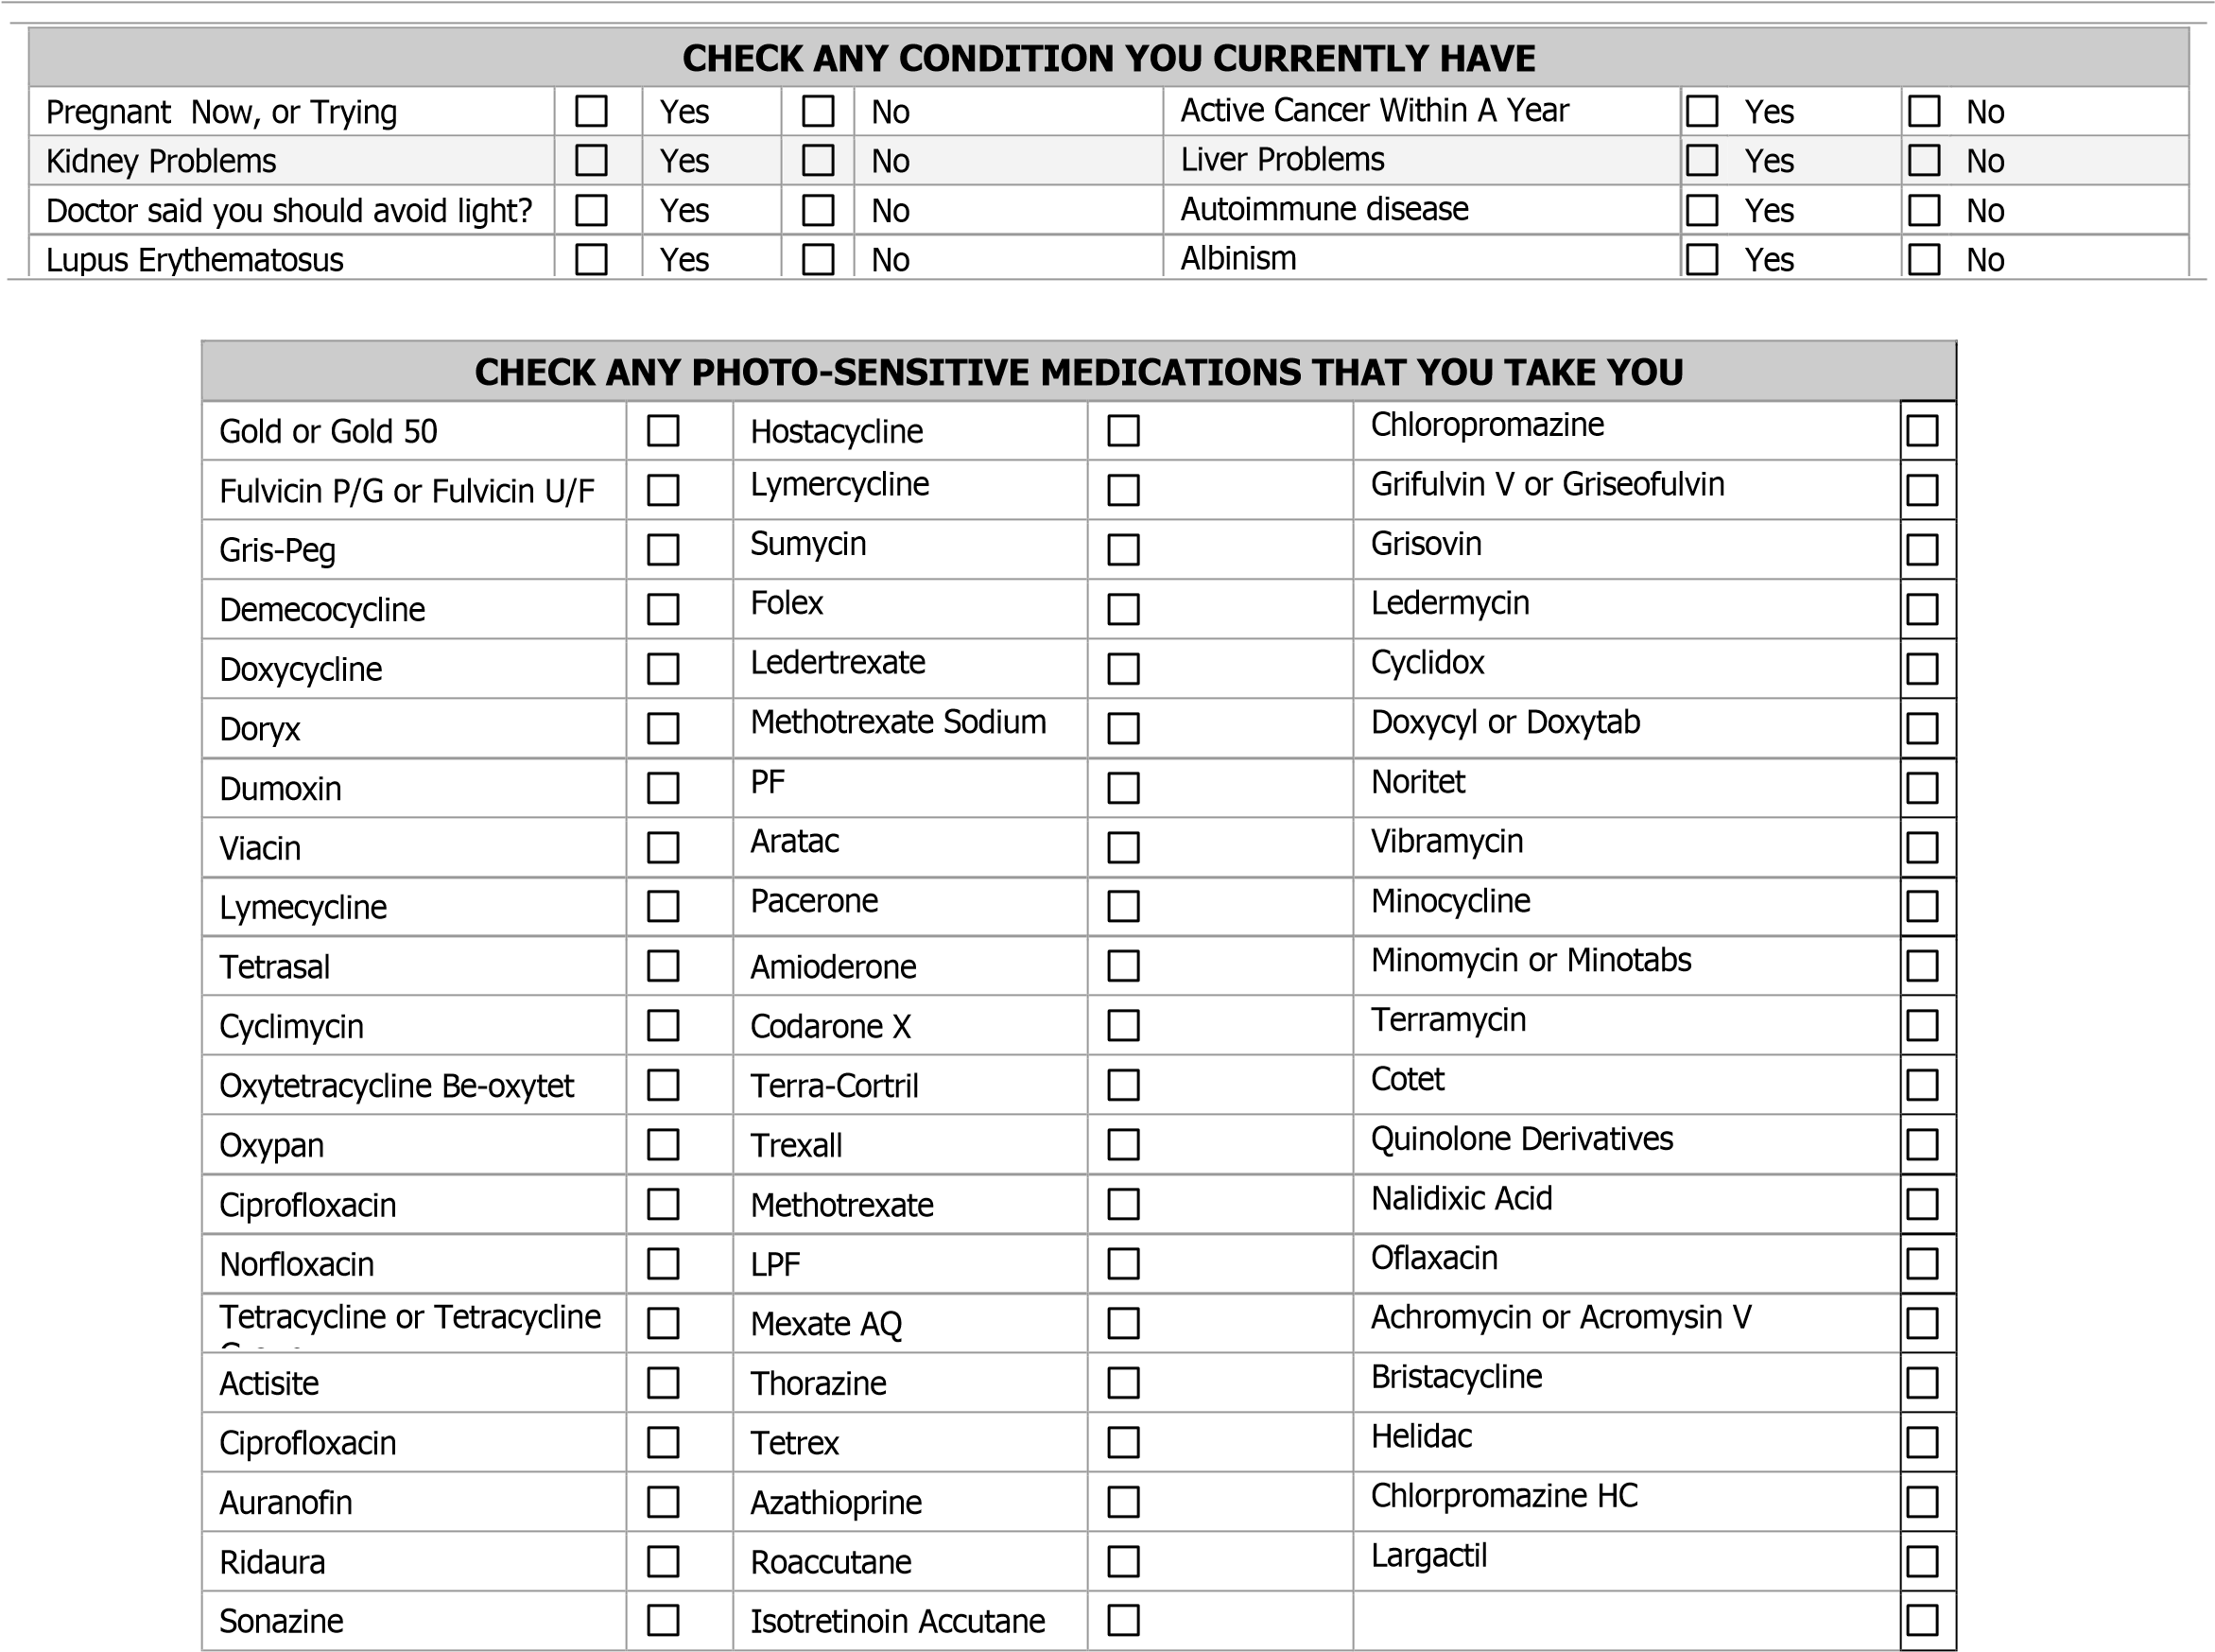

_________________________________________________
Client Signature Date

Rev. 01/10/2020

