Weight Loss New Patient Form
Dr. Sophie Jacob’s Weight Loss Center

Name: Birth Date:
Address: City/State: Zip Code:
Cell#: _________________ Home#___________ ______ Work#:
Email: Occupation:

How did you hear about our weight loss program? (Please Circle)
Email Facebook Postcard Handout Mail Poster/Sign
Friend Radio TV ad Dr. Sophie Front Desk Weight loss talk

Health and Wellness History

Has your doctor advised you to lose weight?
Do you have any dietary restrictions?

Are you taking any medication?
How often do you exercise?
What type of exercise do you do?

 | Daily | 3 or more per week | 1-2 times per week | 1-2 times per month | Less than once a month | Never
Standing or Walking :
Work or Sit at a Desk :
Moderate/Heavy labor :
Tobacco/Smoke :
Alcoholic beverages :
Caffeine / Energy drinks:

Check ALL areas of treatment that interest you:

- Weight Loss
- Cleansing and Detoxification
- More Energy
- Cellulite Reduction
- Non-Invasive
Lipo Laser

Do you know that all treatments listed above are 100% safe? YES NO
Have you ever used any of the above treatments before? YES NO
What do you consider to be your ideal weight?
How much weight do you want to lose?
When was the last time you were at your goal weight?
~ Turn Over To Complete ~

How many times a year do you diet?
What is stopping you from losing weight on your own?
List of surgeries?
Does your weight problem make you physically uncomfortable? YES NO
Does your weight problem cause you physical pain? YES NO
Are you embarrassed by your excessive weight? YES NO
Do you binge eat? YES NO
Do you suffer from uncontrollable cravings? YES NO
Do you eat because of your emotions? YES NO
Do you eat between meals? YES NO If yes, what do you eat?
Do you feel that your eating behaviors are normal? YES NO
How often do you feel tired, or out of energy?
How fast do you want to be slim, trim, and fit?
Is Successful weight loss a top priority? YES NO

Check the following conditions you want help with or more information on:

- Cleansing
- Cellulite
- Hormone Balance
- Neuropathy
- Pain Relief
- Quit Smoking
- Weight Loss
- Thyroid

What is the MOST important element in deciding to use our services?

Effectiveness: “My results are my top priority”
Time: “I want results quickly”
Circle only ONE
of the four answers
Service: “I need extra support along the way”
Affordability: “I need this to be affordable”

I understand that my entire patient history will remain completely confidential and will not be released without express written consent from me.

Signature: Date:

For Doctors Use Only:
Current Weight BMI:
Age Height Ph: FAT%:
Kids # Pregnant? Yes / No Spouse / Other Name

Measurements
Back: Hips: Mid-Abdomen (Belly Button):
Waist: Left Thigh: Right Thigh:

Rev. 01/10/2020 (WL:FORMS:NEW PATIENT FORM)

Real people. Real results. Guaranteed.
1-800-345-4381
Info@MyUltraSlim.com

HEALTH HISTORY QUESTIONNAIRE
Name (Last, First, M.I.): |  |  |  | M F | DOB:
Home Address : |  |  |  |  | Phone:
Email:
Location of Services:

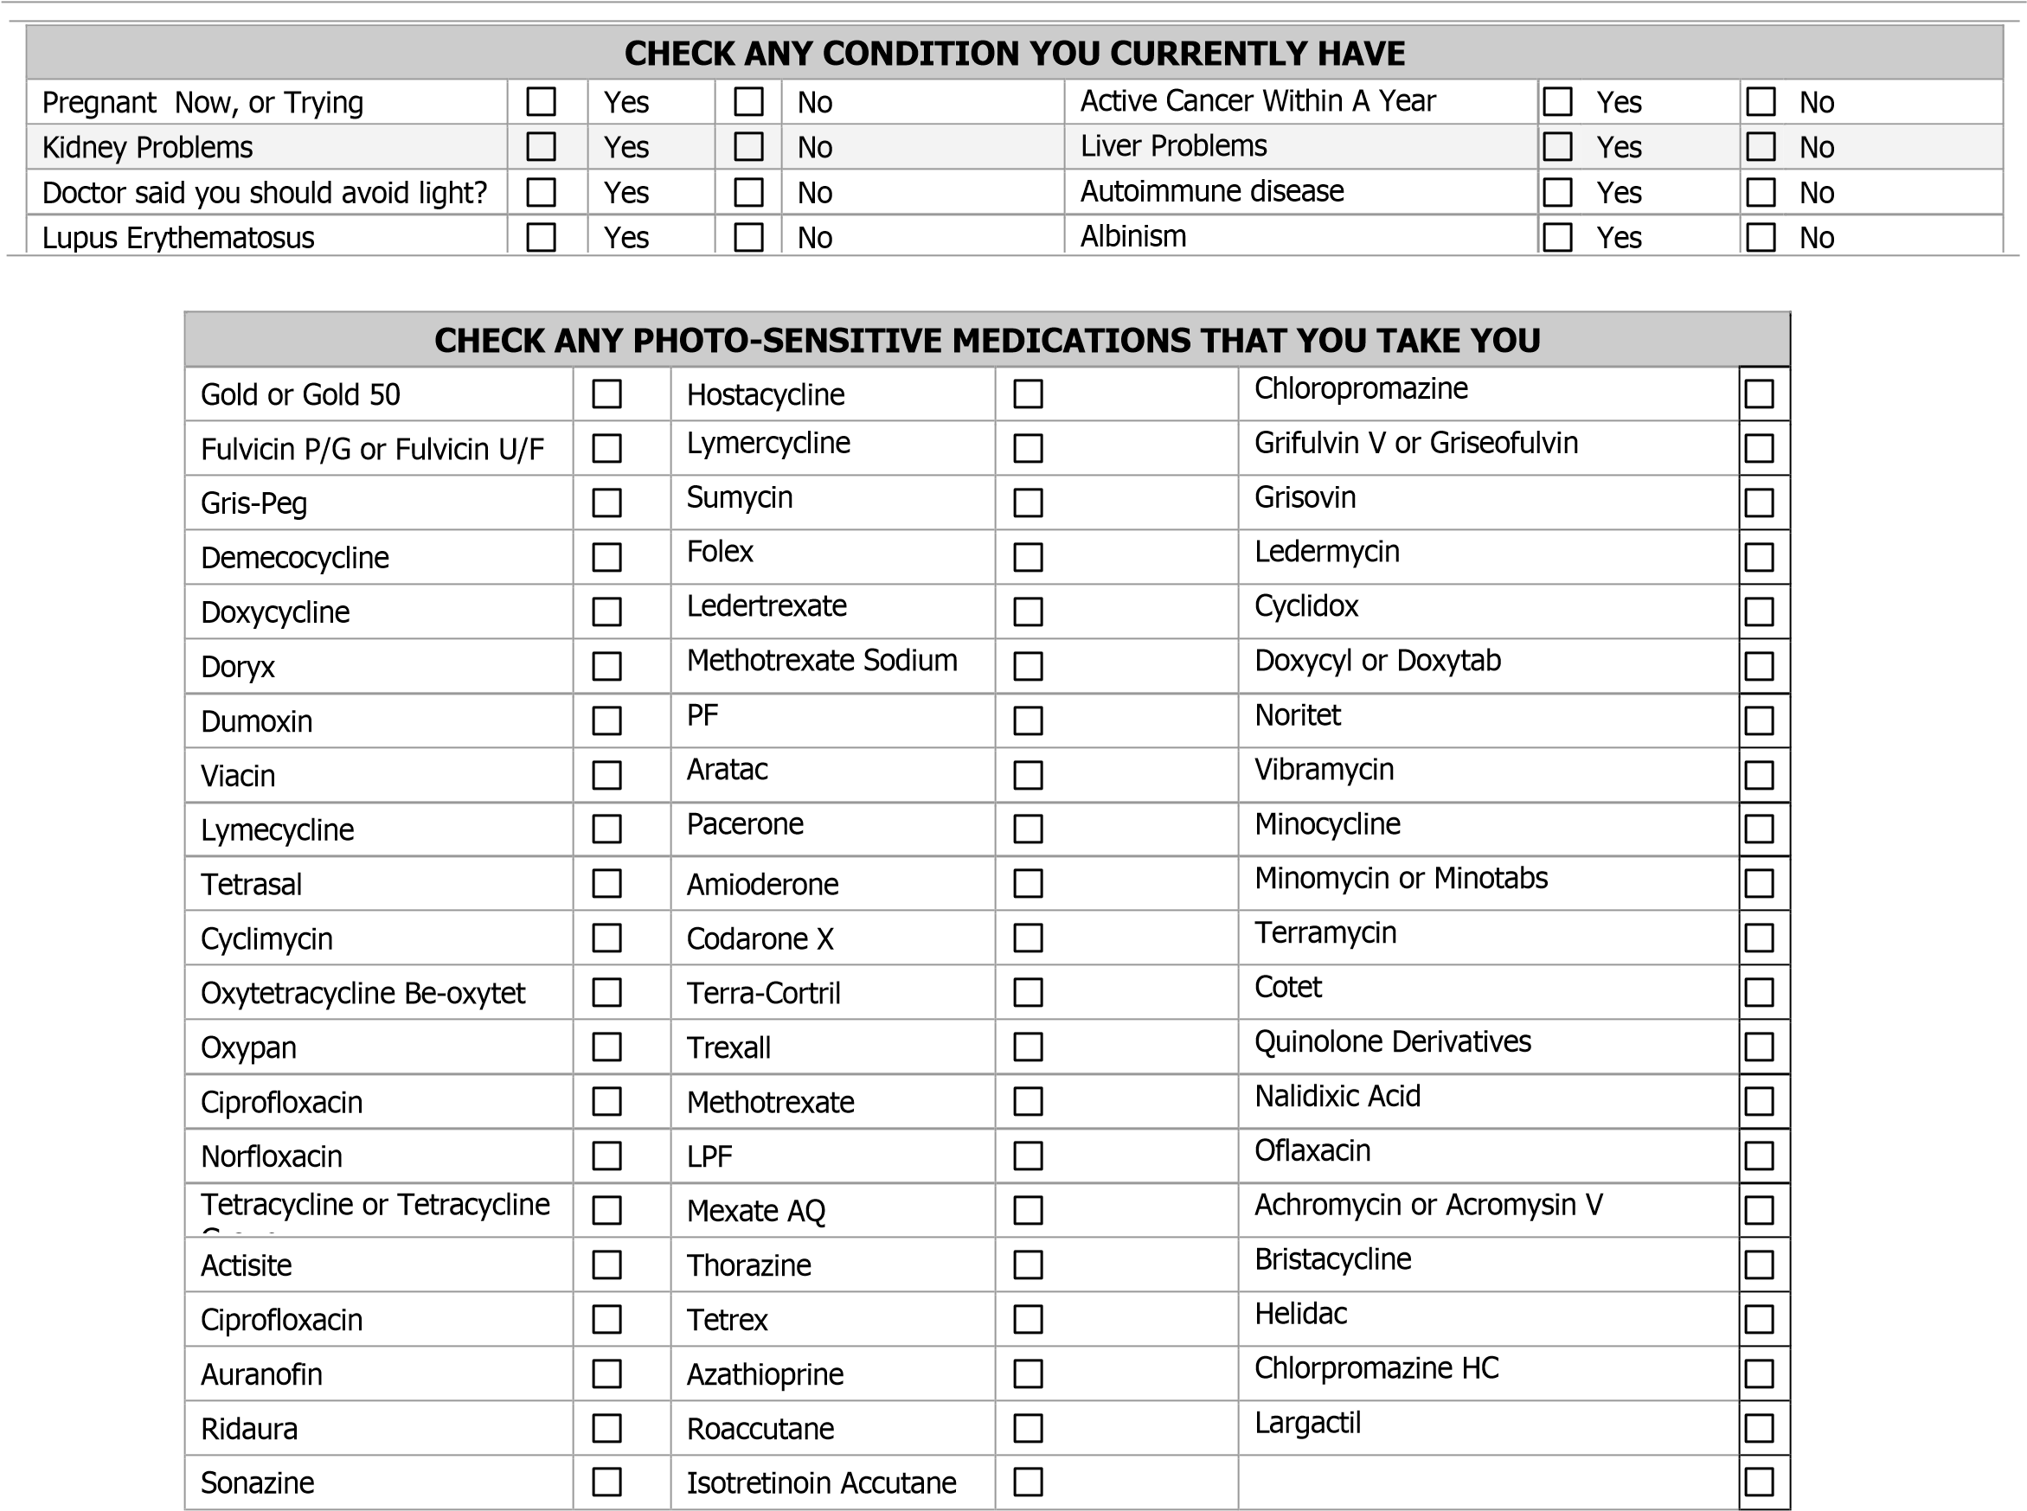

_________________________________________________
Client Signature Date

Rev. 01/10/2020

Where Healing Begins Naturally, L.L.C.
Dr. Sophie Jacob, D.C.
4713 N. 1st Ave.
Tucson, Arizona 85718
PHONE: (520) 891-2882 FAX: (520) 308-4457
dcsophie30@hotmail.com

ACKNOWLEDGEMENT OF RECEIPT OF
NOTICE OF PRIVACY PRACTICES

You may Refuse to Sign This Acknowledgment

I, , have received a copy of this Office’s notice of Privacy Practice

Signature Date

For Office Use Only

We attempted to obtain written acknowledgement of receipt of our Notice of Privacy Practices,
but acknowledgement could not be obtain because:

□ Individual refused to sign

□ Communication barriers prohibited obtaining the acknowledgement

□ Other (Please Specify):

24 HOUR APPOINTMENT POLICY

***We would appreciate 24 hours advance notice in the event you are unable to keep your scheduled appointment or have the need to reschedule. ***

Please note that a charge of $25.00 for any missed appointment without a 24 hour notice will be enforced.

We are committed to your health and well-being, and we thank you for your cooperation in this regard.

By signing you agree to the terms and conditions stated above.

Signature: __________________________________ Date: _______________

